
Business Question and Visualization Report

Date | 02 November 2026
Team ID | NA
Project Name | Electric Vehicle Market Performance & Insights
Maximum Marks | 5 Marks

Visualization development refers to the process of creating graphical representations of data to facilitate understanding, analysis, and decision-making. The goal is to transform complex datasets into visual formats that are easy to interpret, enabling users to gain insights and make informed decisions. Visualization development involves selecting appropriate visual elements, designing layouts, and using interactive features to enhance the user experience. This process is commonly associated with data visualization tools and platforms, and it plays a crucial role in business intelligence, analytics, and reporting
Business Questions and Visualisation
The process involves defining specific business questions to guide the creation of meaningful and actionable visualizations in Tableau. Well-framed questions help in identifying key metrics, selecting relevant data, and building visualisation that provide insights.
Business questions answered in my Tableau workbook:
1. Which vehicle categories generate the highest annual EV sales?
  - Visualization: Horizontal bar chart – SUM(Annual Sales Units) by Category, sorted – sheet “EV Sales by Vehicle Category”.
  - Scenario(s): 1, 2
  - Insight: Two-Wheeler Scooters sell the most (85.0 M units), followed by Sedans (78.3 M), Compact SUVs (76.1 M) and Hatchbacks (76.1 M). Heavy vehicles sell the least – Electric Trucks 6.6 M, Pickup Trucks 6.5 M and Electric Buses 5.3 M.
  - Screenshot:
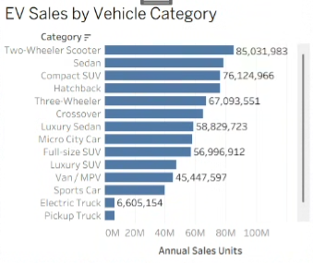

2. How are EV sales spread across the world’s market regions?
  - Visualization: Horizontal bar chart – SUM(Annual Sales Units) by Market Region – sheet “EV Sales Distribution Across Market Regions”.
  - Scenario(s): 2
  - Insight: Sales are very evenly spread: Europe leads with 112.5 M units, followed by South Asia (111.3 M) and Asia Pacific (111.1 M), while Africa is lowest at 108.3 M. Every region holds about 14% of the market, so no single region dominates.
  - Screenshot:
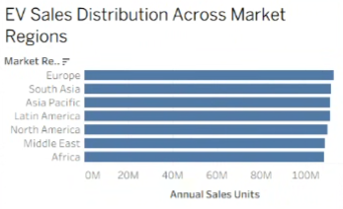

3. Which manufacturers lead the EV market by annual sales?
  - Visualization: Horizontal bar chart – Top 10 Manufacturers by SUM(Annual Sales Units) – sheet “Top 10 EV Manufacturers by Annual Sales”.
  - Scenario(s): 1, 2
  - Insight: SurgeWorks leads with 4.88 M units, followed by CurrentMobility (4.78 M) and ElektraMobility (4.75 M). The top 10 brands together hold only about 6% of total sales, showing a highly fragmented, competitive market.
  - Screenshot:
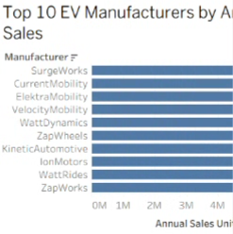

4. Which manufacturers have the most satisfied customers?
  - Visualization: Bar chart – Top 10 Manufacturers by AVG(Customer Rating) – sheet “Top 10 Manufacturers by Customer Rating”.
  - Scenario(s): 1, 2
  - Insight: ElektraDynamics has the highest average customer rating (4.17 / 5), followed by ChargeWorks (4.15) and WattMotors (4.14). The overall average is 4.08, so the best brands are only slightly ahead – satisfaction is high across the market.
  - Screenshot:


5. How does driving range compare across vehicle categories?
  - Visualization: Horizontal bar chart – AVG(Range km) by Category, sorted – sheet “Average Driving Range by Vehicle Category”.
  - Scenario(s): 1, 3
  - Insight: Luxury Sedans have the longest average range (549 km), then Luxury SUVs (525 km) and Full-size SUVs (476 km). Two-Wheeler Scooters (105 km) and Three-Wheelers (130 km) have the shortest range, matching short urban trips.
  - Screenshot:
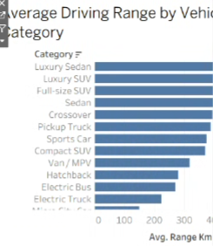

6. Which battery technologies are most widely used?
  - Visualization: Horizontal bar chart – COUNT(Vehicle ID) by Battery Type – sheet “Battery Technology Distribution”.
  - Scenario(s): 1, 2, 3
  - Insight: NMC (33,836 vehicles) and LFP (32,101) are used in about two-thirds of all EVs, followed by NCA (17,234), Sodium-Ion (9,836) and Solid-State (6,993). Solid-State is still an emerging technology.
  - Screenshot:
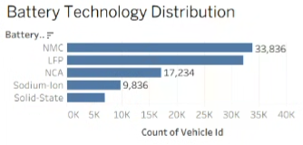

7. Which vehicle categories save the most CO₂ every year?
  - Visualization: Horizontal bar chart – AVG(CO2 Saved Tons per Year) by Category – sheet “Average Annual CO₂ Savings by Vehicle Category”.
  - Scenario(s): 3
  - Insight: Electric Buses (9.05 t/yr), Pickup Trucks (9.01) and Electric Trucks (8.96) save about three times more CO₂ per vehicle than passenger cars (≈3.0 t/yr), while two- and three-wheelers save about 1.6 t/yr. Electrifying heavy vehicles gives the biggest environmental benefit.
  - Screenshot:
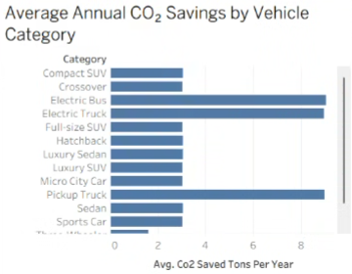

8. How have annual EV sales changed across model years 2018–2026?
  - Visualization: Line chart – SUM(Annual Sales Units) by Model Year – sheet “EV Sales by Model Year”.
  - Scenario(s): 1, 3
  - Insight: Sales stay in a steady band of 82.6 M–88.1 M units per model year. The 2021 models sold the most (88.1 M) and the 2025 models the least (82.6 M), so demand is stable rather than falling.
  - Screenshot:


Total: 8 business questions and visualisations.

